Lecture 7: Chapter 4: Mathematical Functions, Characters, and Strings
Announcements

Reading:
- Chapter 4

Today’s Goals
- Math functions
- Char Data Type
- Char Unicode/ASCII Code/Operations
- String Type
- Debugging

Today's Terminology

Terminology
- Mathematical Functions
  - sin, cos, tan, asin, acos, atan
  - toRadians, toDegrees
  - exp, log, log(10)
  - pow, sqrt
  - cell, floor
  - rint, round
  - min, max
  - abs
  - random

- Char data type
  - Represents a single character

- Encoding
  - When you encode, you are using something to represent something else

Math Functions

Using methods that have been pre-defined in Java to perform mathematical functions.

Math Class
- Provides methods that perform mathematical calculations beyond the basic operators +, -, *, /, %
- The Math class is part of the java.lang package – which means it is imported by default.

Quick Peek into Objects
- Dipping into objects again - just a little bit to ease you into understanding objects.
Class - A class is a container for one or more methods
Method - Methods contain statements that perform a task
Objects - Represents an entity like a car, house, circle, dog, etc.

- A class is
  - Used to construct an object – it defines an object’s attributes and behaviors – it’s the blueprint

- We’ll create our own classes and objects in the future – Chapter 9
- For now, we are creating objects from predefined classes

- How do we use predefined classes?
- Import the class
- Create an object from that class
- Use methods defined for that object

- We've used the Scanner class to create a Scanner object
  - We create a Scanner object - below the object is named "userInput"
  - We call methods on that object to do “things” - like reading input from user - userInput.nextInt();

import java.util.Scanner;
public class Assignment2 {
public static void main(String[] args) {
// Create a Scanner object to read input from the user
Scanner userInput = new Scanner (System.in);
....
}
}

Back to Match Class
- Math class is different. We DO NOT create a Math object!
- You will NOT say the following when dealing with the Math class

Math myMath = new Math();

If you try this the complier will complain with something like "The constructor is not visible"

- A constructor is a method that is called to "create" an object
- The reason the above error happened:
  - In the Math class this "constructor" method is private
  - You don't have access to private methods in a class
- How can we use the Math class if we cannot create a Math object?
  - ALL methods in the Math class are what we call static methods – more on this later, but for now:
  - Static methods
    - Allow you to call the methods in a class without creating an object of the class
    - Are NOT associated with a specific object of the class
    - To call static methods you use the class name:

double squareRoot = Math.sqrt(25);

Constants
- There are two constants in the Math class
  - PI => 3.14159...
  - E => 2.71828... (base of natural log)

Trigonometric Methods
- sin(radians), cos(radians), tan(radians)
  - Give these methods an angle in radians (note: value you "give" to a method is called an argument)
  - The returned value is in radians

double sinOfZero = Math.sin(0); // Argument is 0, returned value in sinOfZero
System.out.println ("Math.sin(0) = " + sinOfZero); // Displays 0.0

- toRadians(degree), toDegree(radians)
  - Examples when we have a value that is in degrees

double angleInRadians = Math.toRadians(60);
System.out.println("Sixty degrees = " + angleInRadians + " radians");

double sinOfAngle = Math.sin(angleInRadians);
System.out.println ("Math.sin(60) = " + sinOfAngle);

- asin(a), acos(a), atan(a)

Note
- Use Eclipse to see what is in Math class
- Typing Math. -- you can see there are two constants

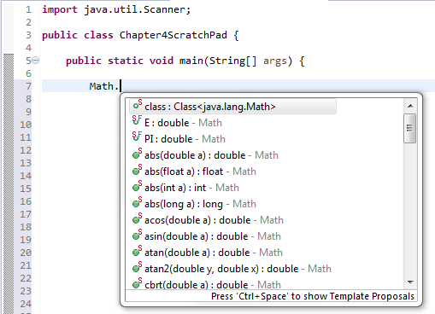

- Typing Math.sin -- you can see what the sin method is expecting and what value it returns

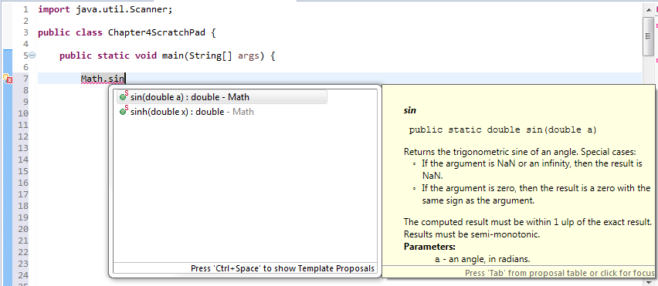

Exponent Methods
- exp(x)
- log(x)
- log10(x)
- pow(a, b)
  - Returns the value of a raised to the power of b

double raisedToThePower = Math.pow(10, 2); // Returns 100.0
System.out.println ("10 raised to the power of 2 = " + raisedToThePower);
- sqrt(x)
  - Returns the square root of x (x >= 0)

double squareRoot = Math.sqrt(25);
System.out.println ("Square root of 25 = " + squareRoot);

Rounding Methods
- ceil(x)
  - Rounds x up to nearest integer
- floor(x)
  - Rounds x down to nearest integer
- rint(x)
  - Rounds x up to nearest integer - if equally close to two integers - returns even one

System.out.println ("Round 3.4 up with method rint = " + Math.rint(3.4));// 3.0
System.out.println ("Round 3.5 up with method rint = " + Math.rint(3.5));// 4.0
System.out.println ("Round 3.6 up with method rint = " + Math.rint(3.6));// 4.0

- round(x)
  - Returns int if x is a float or returns long if x is a double rounded to nearest integer value

int x = Math.round (81.7); This won't work? Why?
81.7 is a what? -> a double so
need to store result in a long not an int

int intResult = Math.round (81.7f); Returns 82 - which is an int
long longResult = Math.round(81.7); Returns 82 - which is a long
double doubleResult = Math.round(81.7); Returns 82.0 - which is a double

Min, Max, Abs Methods
- min (x, y)
  - Returns the minimum of the two arguments
  - Can take int, long, float, or double (i.e., in Java we call this "overloading" a method)

int x = Math.min (81, 7); // Returns 7
double y = Math.min (81.7, 330.13); // Returns 81.7

- max (x, y)
  - Returns the maximum of the two arguments
  - Can take int, long, float, or double (i.e., in Java we call this "overloading" a method)

int x = Math.max (81, 7); // Returns 81
double y = Math.max (81.7, 330.13); // Returns 330.13

- abs(x)
  - Returns absolute value of the argument
  - Can take an int or double

int x = Math.abs(-81); // Returns 81
double d = Math.abs(81.7); // Returns 81.7

- Note
  - For overloaded methods - like min and max - Eclipse will show you the different ways to call

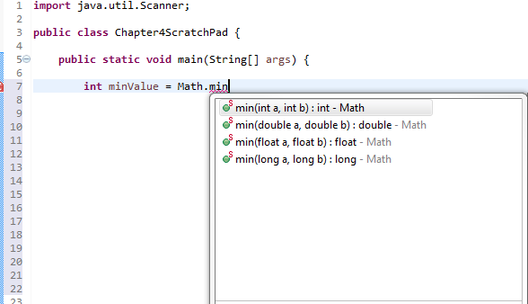

Random Method
- Math.random()
- Returns a double between 0.0 and up to but not including 1.0

double randomNum = Math.random();
System.out.println("double randomNum = Math.random() = " + randomNum);

- Returns a integer between 0 and up to but not including 10

int randomInt = (int)(Math.random() * 10);
System.out.println("int randomInt = (int)(Math.random() = " + randomInt);

- Returns a random number between a and a+b excluding a+b (see book p.124)

a + (int)(Math.random() * b);

int result1 = (50 + int)(Math.random() * 50); // typo in book p.124
int result2 = 50 + (int)(Math.random() * 50); // correct

Char Data Type
Data Type
- Tells the compiler what type of data is stored in a variable
- Integer variables - byte, short, int, long
- Floating-point variables - float, double
- Boolean variable – boolean (values are true, false)

Char Data Type
- Values: one single character
- Use single quote to represent a character (doubles quotes are for Strings)

char middleInitial = 'M';
char numCharacter = '4'; // Assigns the character 4 to numCharacter
System.out.println(numCharacter); // Displays the character 4

Notes
- If you place a single character in double quotes it is no longer a char it is a String

char middleInitial = "M"; // Error - cannot convert String to char

Char Unicode/ASCII Code/Operations
Unicode and ASCII Code
- Encoding
  - With encoding, you are using something to represent something else
  - With Unicode and ASCII code a binary representation maps to a char

01100010 represents the char 'b' (ASCII coding scheme - binary representation)
01100010 = 98 (2^7 + 2^6 + 2^5 + 2^4 + 2^3 + 2^2 + 2^1 + 2^1)
0 + 1 + 1 + 0 + 0 + 0 + 1 + 0
64 32 2

64+32+2=98

  - ASCII chart in Appendix B - shows where lowercase 'b' is represented by the decimal number 98

- Unicode and ASCII code are two encoding schemes
- ASCII (American Standard Code for Information Interchange)
  - 8-bit character scheme - shown above for the char 'b'
  - Provides encoding for 128 characters
  - Based on ordering of English alphabet
  - Superseded by UTF-8
- Unicode
  - 16-bit character scheme (which can store the char data type)
  - Encodes every possible language - so it is huge!
  - Requires more space than ASCII
  - Includes ASCII code
  - UTF-8 one of the widely-used encodings
  - Basically, Unicode is a way to assign to each character a unique number, or code point
  - For more information read: http://kunststube.net/encoding/

Escape Sequences for Special Characters
- Notation used to represent special characters - things like tabs, quotes, carriage return, backspace, etc.
- Considered a single character
- Taken as a whole and not individually

\t represents the tab character
\" represents the quote character
\ n represents a linefeed (like pressing enter key)

- Example

System.out.println ("This text is not in quotes but this text \"quoted text\" is in quotes");

Displays - This text is not in quotes but this text "quoted text" is in quotes

Casting
- char can be cast to numeric values (byte, short, int, long, float, double)
  - Takes the character's Unicode and casts it into a numeric value

int x = (int)'b'; Casting the char ‘b’ to an int
System.out.println ("Value in integer x = " + x); Displays: Value in integer x = 98

float xx = (float)'b';
System.out.println ("Value in float xx = " + xx); Displays => Value in float xx = 98.0

- Numeric values (byte, short, int, long, float, double) can be cast to char
  - Only lower 16 bits are cast into char - other bits ignored

char c1 = (char)98; Casting the integer 98 to a char
System.out.println ("Value in c1 = " + c1); Displays: Value in c1 = b

byte number = 98; 98 fits in a byte so this is fine
char c2 = (char)number;
System.out.println ("Value in c2 = " + c2); Displays: Value in c2 = b

float number = 98.6f; Declaring a float (by including the f)
char c3 = (char)number; 1st cast 98.6 into int becomes 98
2nd cast 98 to char
System.out.println ("Value in c3 = " + c3); Displays => Value in c3 = b

- Numeric operations can be applied to char
  - The char will automatically be cast into a numeric value
Converts ‘b’ to 98 automatically
int value = 'b' + 0;
System.out.println ("The expression \"b + 0\" = " + value);

Displays - The expression "b + 0" = 98

Comparing
- Use relational operators to compare two characters just like you do for numbers
- The Unicode is what is used in the comparison
- At times, we need to perform test to determine
  - If character is a number
  - if character is a letter
  - if character is uppercase or lowercase

char someChar = input.next().charAt(0);
if ((someChar >= 'A') && (someChar <= 'Z')) {
System.out.println ("An uppercase letter was entered.");
}
else if ((someChar >= 'a') && (someChar <= 'z')) {
System.out.println ("A lowercase letter was entered.");
}
else if ((someChar >= '0') && (someChar <= '9')) {
System.out.println ("A number was entered.");
}

Testing
- Use the static methods in Character class to test characters
  - Contains a bunch of methods that do tests on characters
  - Like Math class - you don't create an object of this class, use class name to access static methods

- These methods return true or false
  - isDigit(someChar)
  - isLetter(someChar)
  - isLetterOfDigit(someChar) // True if someChar is letter or digit
  - isLowerCase(someChar);
  - isUpperCase(someChar);

Converting
- These methods return a char converted to lowercase or uppercase
  - toLowerCase(someChar);
  - toUpperCase(someChar); With static methods must include class name
write as Character.isUpperCase
if (Character.isUpperCase(char1)) {
System.out.println("char1 is an uppercase letter");
}

String Type

Primitive Data Type
- Tells the compiler what type of data is stored in a variable
- Integer variables - byte, short, int, long
- Floating-point variables - float, double
- Boolean variable – boolean (values are true, false)
- Character variables - char

String Data Type
- A sequence of characters is considered a string
- String is different from the other data types because
  - it is NOT a primitive data type
  - it is an object – the reason it is capitalized - predefined class like Scanner, Math, System, etc.

- We can create strings in two ways:

  - Create an object (chapter 10)
String studentName = new String("Silly Willy"); // Chapter 10

  - Use a reference (chapter 4)
String studentName = "Silly Willy"; // Chapter 4

- For now, declare a reference variable to be a String and then perform actions on that variable
- Use double quote to represent a string

String studentName = "Silly Willy"; // This is a valid string

Notes
- Remember a char is in single quotes and a String is in double quotes

char middleInitial = "M"; Error - cannot convert String to char
char middleInitial = 'M'; Correct

string studentName = "Max" Error - first letter must be uppercase "String" since object
String studentName = 'Max'; Error - Strings require double quotes, not single quotes
String studentName = "Max"; Correct

String Operations

Example
- Use string "Silly Willy" for these examples

String myString = "Silly Willy";

S | i | l | l | y |  | W | i | l | l | Y
0 | 1 | 2 | 3 | 4 | 5 | 6 | 7 | 8 | 9 | 10

Extracting a Character from a String
- charAt(index)
  - Returns the character at the specified index within a string
  - index runs from 0 to length of string minus 1

System.out.println("The 1st letter in student's name is " + myString.charAt(0));
System.out.println("The last letter is " + myString.charAt(myString.length()-1));

- Note
  - If you attempt to access a character in a string outside the strings limits you get an error
  - What if I used a plus sign (+) in last print statement?

System.out.println ("The last letter is " + myString.charAt(myString.length()+1));

Attempting to access character outside limits of string

Exception in thread "main" java.lang.StringIndexOutOfBoundsException: String index out of range: 12
at java.lang.String.charAt(Unknown Source)
at Chapter4ScratchPad.main(Chapter4ScratchPad.java:173)

Reading Characters

Reading a Character from Console
- Note: the Scanner DOES NOT have a nextChar() method
- Two methods are needed to read a character

  - First use the Scanner's - next() or nextLine() method
  - Then use String's - charAt()

System.out.print("Enter one character - any character! ");
String aString = input.next();
char someChar = aString.charAt(0);
System.out.println("Character entered = " + someChar);

  - Shortcut way to write this

System.out.print("Enter one character - any character!");
char someChar = input.next().charAt(0);
System.out.println("Character entered = " + someChar);

- How does this work
  - 1st next() method is executed
    - next() reads a string from the console
    - in the above code it is a string containing one character
Now we have a string!

  - 2rd charAt(0) method is executed on the string
    - charAt(0) returns the character at the 0th position in the string - so 1st character

  - 3rd someChar is assigned the character at the 0th position

Debugging

Will discuss in lecture #8

What is Debugging?
- The process of identifying and removing logical/runtime errors from your code

Approaches to Debugging
- Print values of variables when code is executing to track down issues
- Use the debugger that comes with your IDE
  - A debugger allows you to:
    - Step through the code one statement at a time
    - Step into or over methods
    - Set breakpoints - a place where the code will stop executing
    - Examine variables - watch variables - modify variables
    - Display the call stack

Document
- After assignment #3 is due, there will be an extra document under the assignments link that shows the steps to use the debugger

On Your Own Book Exercises:

Exercise 4.14 (Convert letter grade to number)

Write a program that prompts the user to enter a letter grade A, B, C, D or F and displays its corresponding numeric value 4, 3, 2, 1 or 0.

Sample Output
Enter a letter grade: A
The numeric value for grade A is 4

Sample Error Output
Enter a letter grade: R
R is an invalid grade

Java Code (examples of using charAt, Character, switch statement)

import java.util.Scanner;

public class Exercise04_14 {

public static void main(String[] args) {
// Create a scanner object to perform console input
Scanner input = new Scanner(System.in);

// Prompt user for a letter grade - A, B, C, D, F to be
// converted to a numeric value
System.out.print("Enter a letter grade: ");
char grade = input.nextLine().charAt(0);

int value = 0;
if ((Character.toUpperCase(grade) == 'A') ||
(Character.toUpperCase(grade) == 'B') ||
(Character.toUpperCase(grade) == 'C') ||
(Character.toUpperCase(grade) == 'D') ||
(Character.toUpperCase(grade) == 'F')) {

// Convert letter grade to a numeric grade
switch (grade) {
case 'A': value = 4; break;
case 'B': value = 3; break;
case 'C': value = 2; break;
case 'D': value = 1; break;
case 'F': value = 0; break;
}
System.out.println("The numeric value for grade " + grade + " is " + value);
}
else {
System.out.println(grade + " is an invalid grade");
}
} // end main
}

